Lab EFS: Create file system

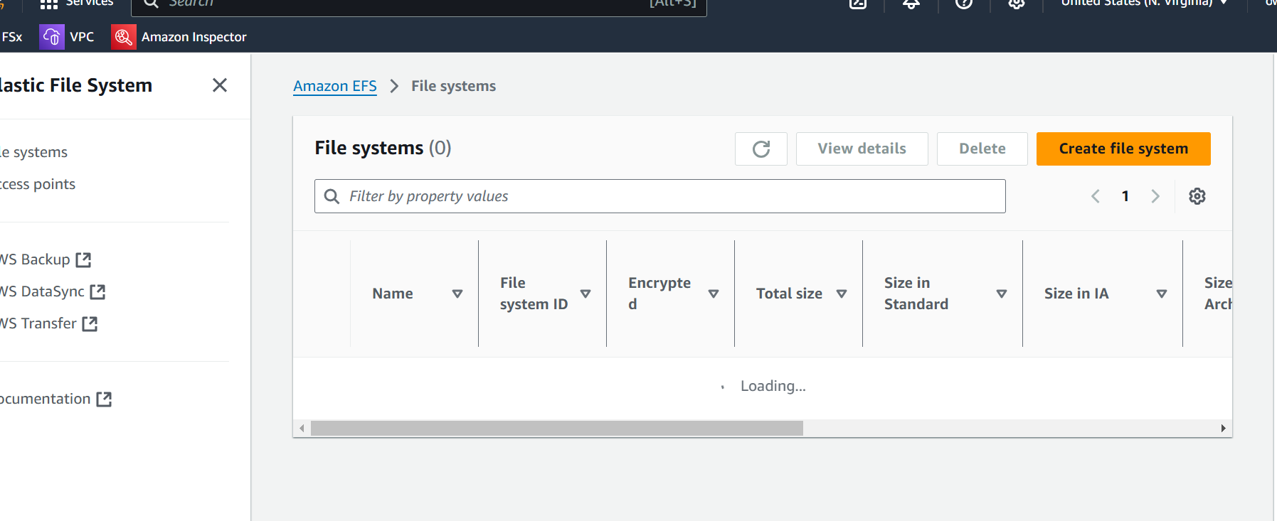

Provide name

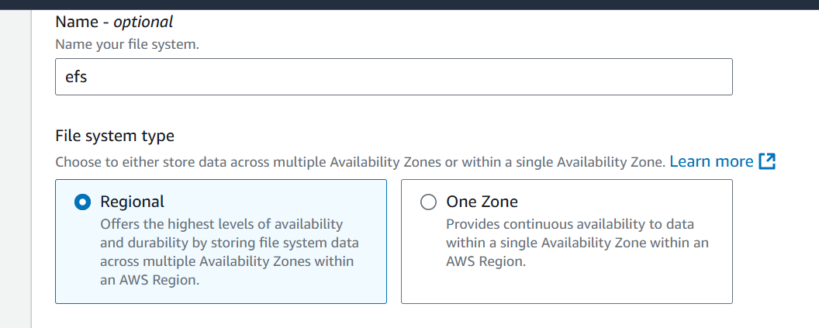

Click on next

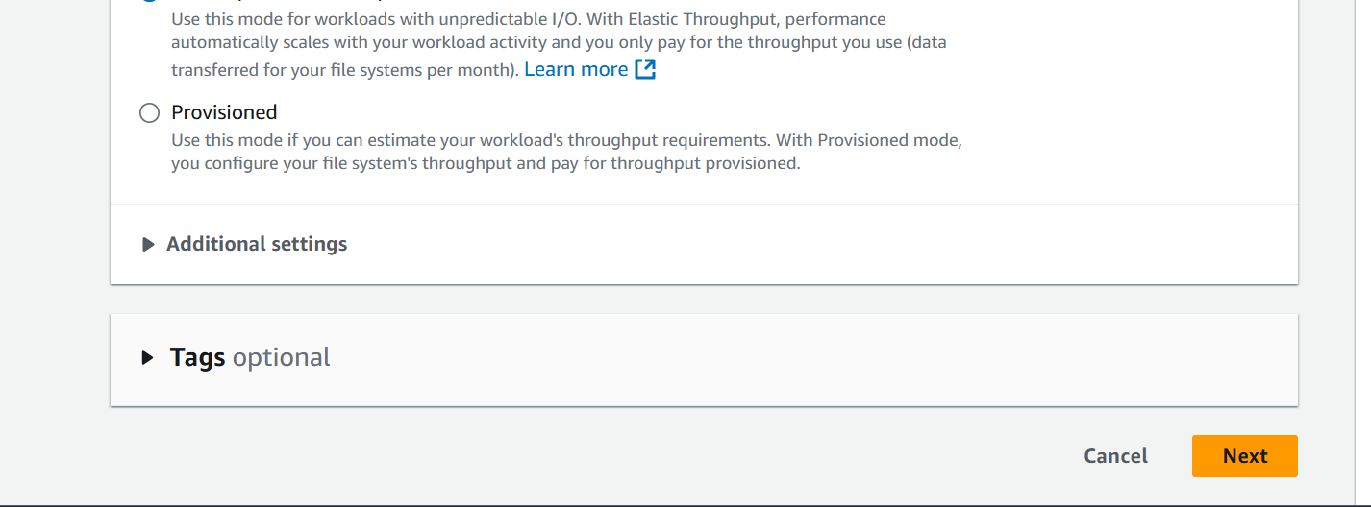

Mount target

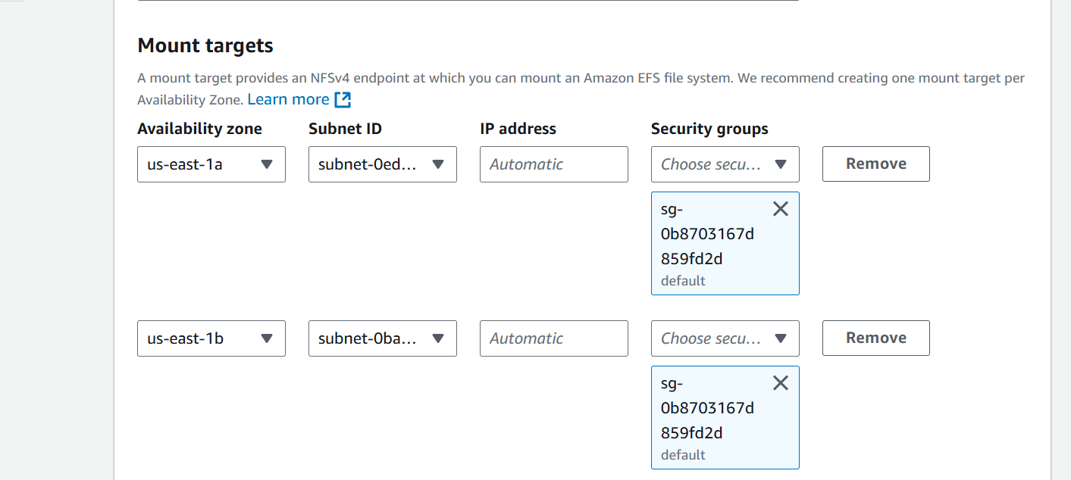

Provide access

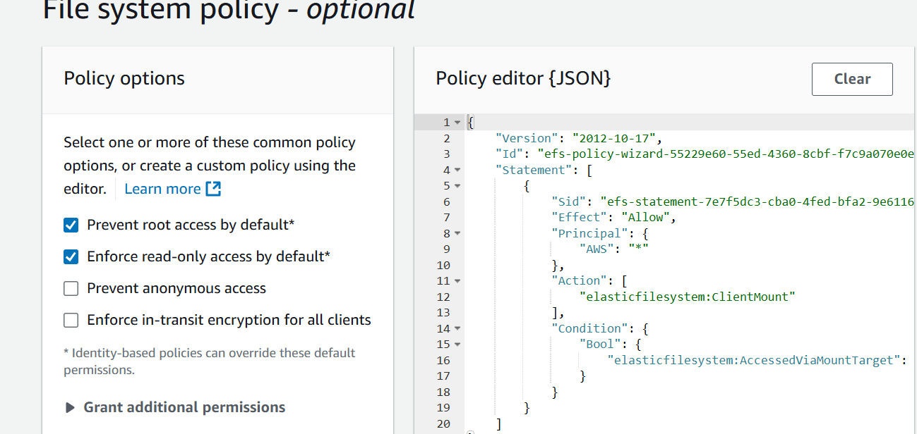

Click on Create

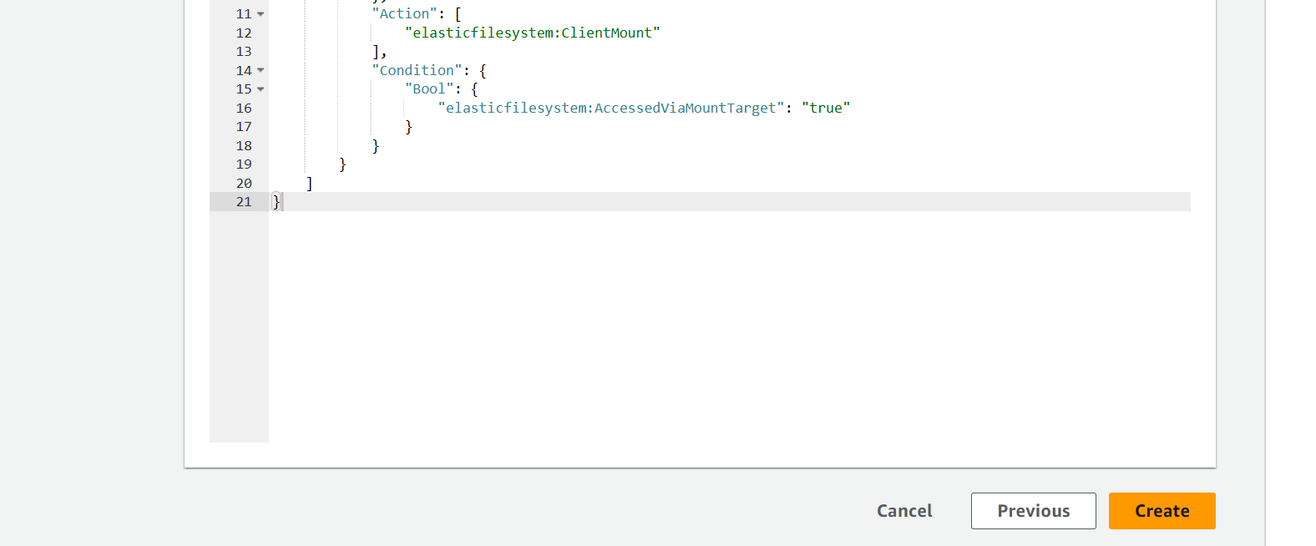

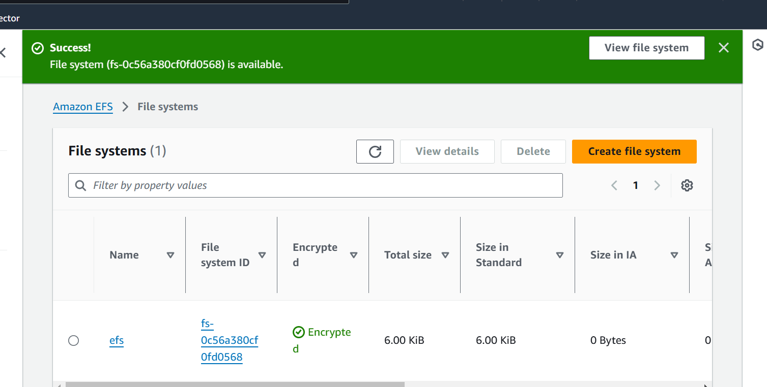

Click on attach

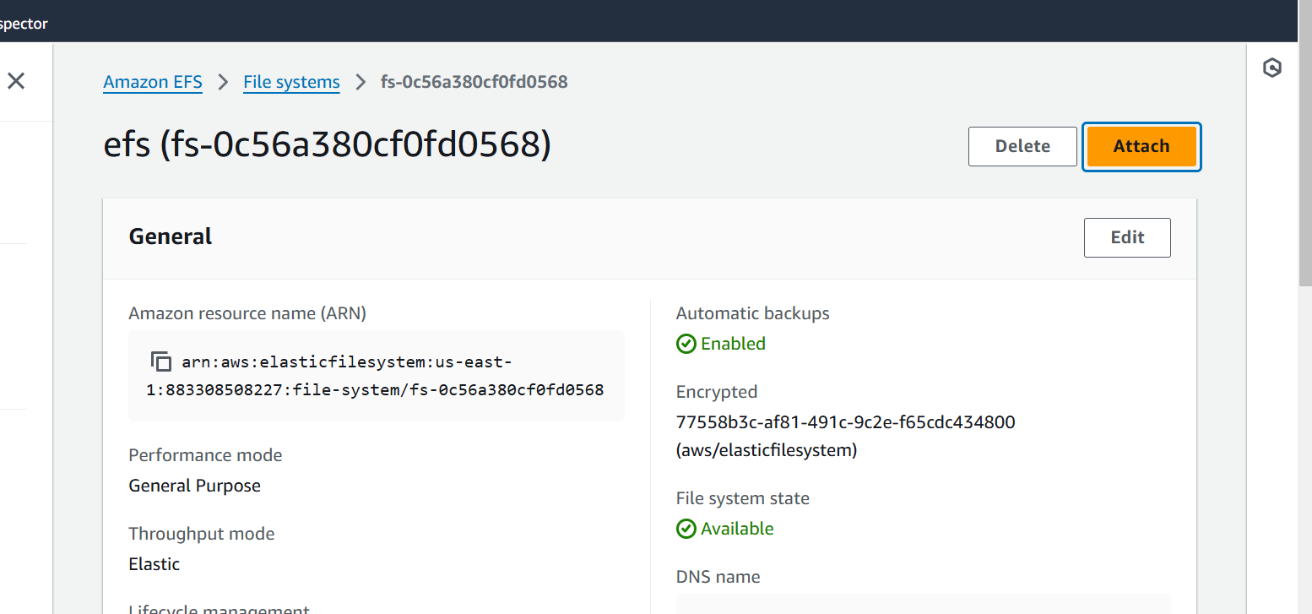

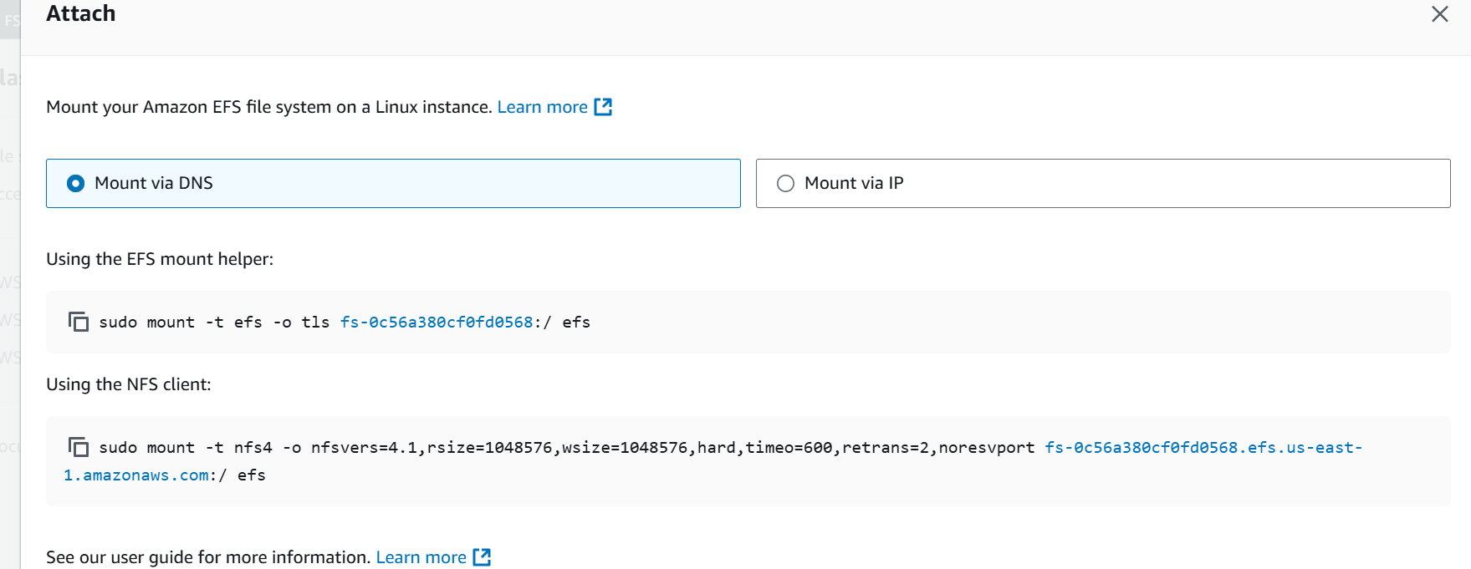

**Configure Security Groups**

1. Edit Security Groups:

* Ensure the security groups associated with your EC2 instances allow inbound NFS traffic (port 2049).

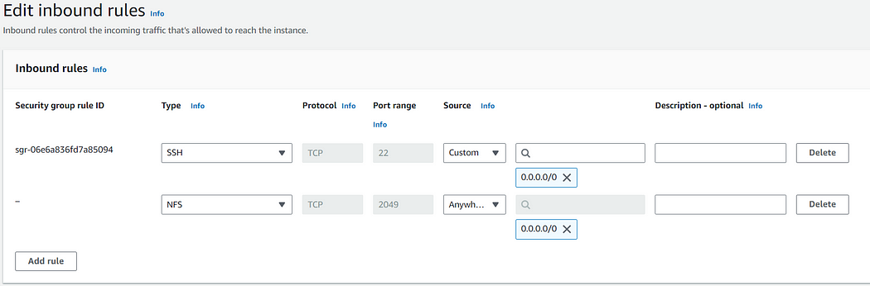

* Also, configure the EFS security group to allow inbound NFS traffic from the security groups of your EC2 instances.

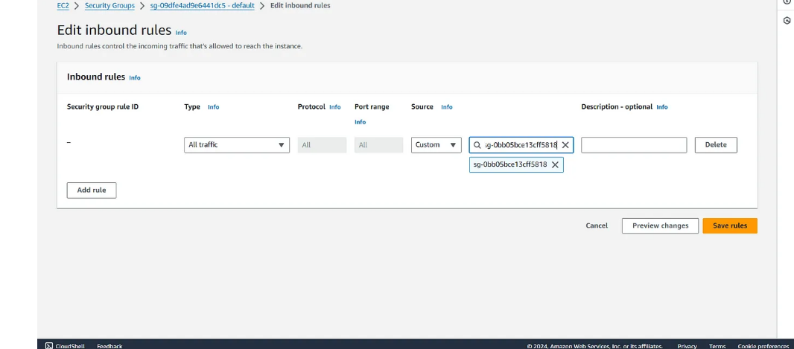

**Step 3: Mount the EFS File System on EC2 Instances**

1. Install NFS Utilities:

* SSH into your EC2 instances, in the EC2, we have apache web server installed and we have to mount this EFS storage to our document root and for this first we need to install NFS client utilities. For Amazon Linux, use:

sudo yum install nfs-utils -y

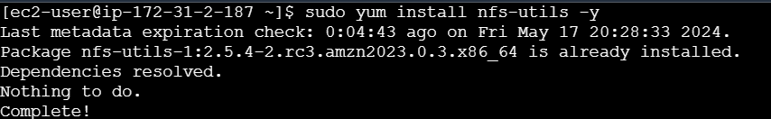

2. Mount the EFS File System:

* Mount the EFS directory to documentRoot, i.e, /var/www/html :
* Copy the Dns Name of your EFS storage:

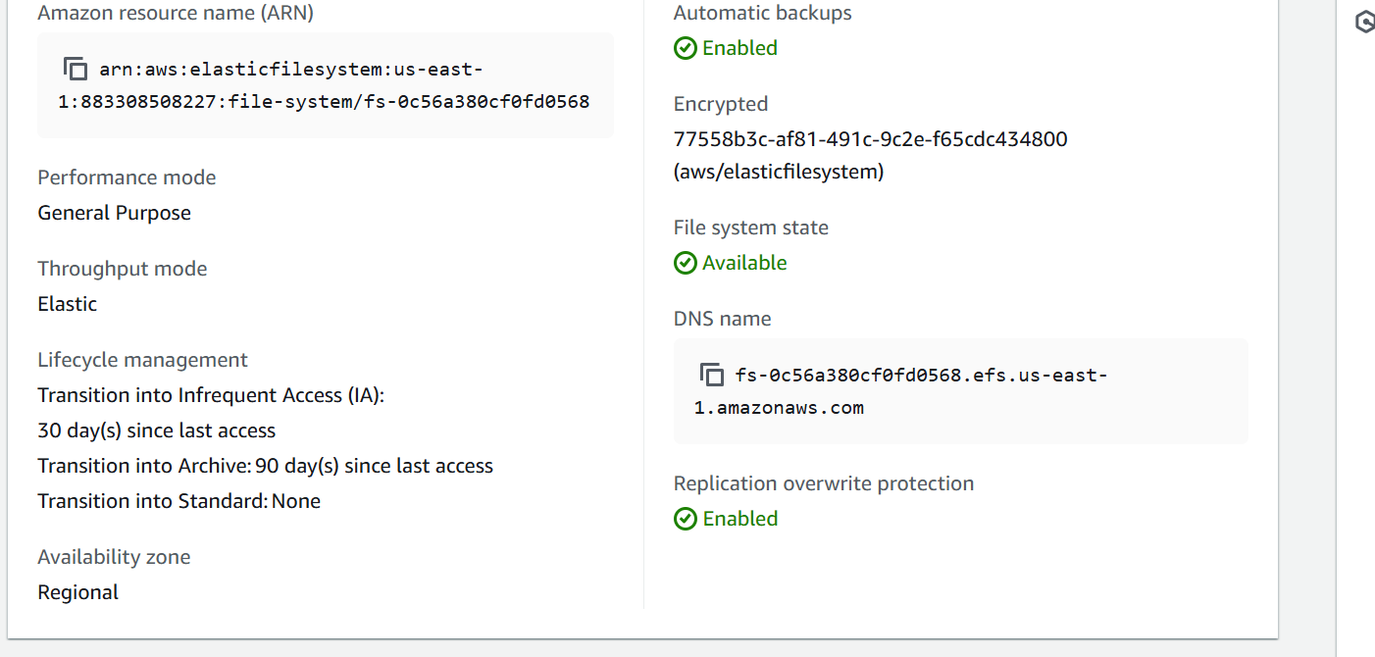

* Go to your EC2-Instance and mount this to your directory.

sudo mount fs-0f125e4a9f2b41406.efs.us-west-1.amazonaws.com:/ /var/www/html/